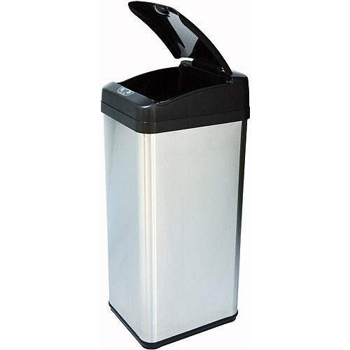

A new way to throw s**t out! Now introducing the all new residential SmartCan! With weight and distance sensors that are programmed to notify you when your garbage can is full to the ideal weight or height, you will not have to worry about ripping the bag nor hurting your back from such a heavy load! In the next phase of the Smart-Can we will need YOU as a beta tester. Visit the link for more information and to join our mailing list/beta!

## Expected Date: January 1, 2015

Coming Soon Near You!

The SmartCan

# http://smartcan.brace.io